

  - Xorijiy tillarga ixtisoslashtirilgan
  - maktab-internati
  - 7-sinfga qabul imtihoni
Ingliz tili test spesifikatsiyasi

Transforming societies
through education

Mundarija
1. Xorijiy tillarga ixtisoslashtirilgan maktab-internati 2
2. Qabul imtihonlari jarayonining tuzilishi 2
3. Saralash testining maqsadi 3
4. Ingliz tili testi 3
5. Ingliz tili testining shakli 4
6. Namunaviy savollar 5
Muloqotning funksional maqsadini anglash 6
Mos so‘zni yoki grammatik shaklni aniqlash 7
Mos so‘zni yoki grammatik shaklni aniqlash 7
Tafsilotlarni tushunish 8
Tafsilotlarni tushunish 9
Tafsilotlarni tushunish 10
7. Qabul jarayonida nomzodlarni saralash qoidalari 11

Xorijiy tillarga ixtisoslashtirilgan maktab-internati
O‘zbekiston Respublikasi Ixtisoslashtirilgan ta’lim muassasalari agentligi tomonidan o‘quvchilarga xalqaro standartlarga mos sifatli umumiy o‘rta ta’lim berish hamda xorijiy tillarni chuqur o‘rganish imkoniyatlarini yaratish maqsadida Xorijiy tillarga ixtisoslashtirilgan xalqaro maktab-internati tashkil etilgan.
Mazkur maktab-internat o‘quvchilarning xorijiy tillarni o‘rganishdagi qobiliyatlarini rivojlantirish va ularni ta’limning keyingi bosqichlarida muvaffaqiyatli faoliyat yuritishga tayyorlashni maqsad qiladi.
Xorijiy tillarga ixtisoslashtirilgan xalqaro maktab-internatining asosiy ustuvor yo‘nalishlari quyidagilardan iborat:
- iqtidorli o‘quvchilarni saralash va o‘qitish hamda ularning har tomonlama rivojlanishi uchun zarur shart-sharoitlarni yaratish;
- xorijiy tillarni fan, muhandislik va axborot texnologiyalari yo‘nalishlari bilan uyg‘un holda chuqur o‘rganishni rivojlantirish;
- o‘qitish va o‘quvchilar bilimini baholashning zamonaviy usullarini joriy etish;
- o‘quvchilarning liderlik, omma oldida nutq so‘zlash, tanqidiy fikrlash va tahlil qilish ko‘nikmalarini rivojlantirish;
- o‘quvchilarning xalqaro fan olimpiadalari va tanlovlarida ishtirok etishini ta’minlash;
- milliy va xalqaro ta’lim muassasalari bilan hamkorlikni rivojlantirish.
Xorijiy tillarga ixtisoslashtirilgan xalqaro maktab-internatining maqsad va vazifalarini qo‘llab-quvvatlash maqsadida Cambridge University Press & Assessment tomonidan tanlov asosidagi qabul imtihoni ishlab chiqilgan.

Qabul imtihonlari jarayonining tuzilishi

Qabul imtihoni ikki qismdan iborat:
- Ingliz tili testi;
- Matematik fikrlash va tanqidiy tahlil ko‘nikmalari testi.
Muammolarni hal qilish va tanqidiy fikrlash ko‘nikmalari birgalikda “Matematik fikrlash va tanqidiy tahlil ko‘nikmalari” deb yuritiladi.
Matematik fikrlash va tanqidiy tahlil ko‘nikmalari testi barcha nomzodlar tomonidan ingliz tilida topshiriladi.

Saralash testining maqsadi

Saralash Qabul imtihonining maqsadi har bir hududdan Xorijiy tillarga ixtisoslashtirilgan xalqaro maktab-internatida ta’lim olish uchun eng munosib nomzodlarni adolatli, xolis va shaffof mezonlar asosida saralashdan iborat.

Saralangan nomzodlar Xorijiy tillarga ixtisoslashtirilgan xalqaro maktab-internatining maqsad va vazifalarini muvaffaqiyatli amalga oshirish imkoniyatiga ega bo‘lgan o‘quvchilar hisoblanadi.

Ingliz tili testi

Ingliz tili testi CEFRning B1–B2 darajalariga mos keladi.
CEFR (Common European Framework of Reference for Languages - Tillar bo‘yicha Umumevropa Kompetensiyalar Tizimi) til bilish darajasini tavsiflash uchun qo‘llaniladigan xalqaro standartdir. Ushbu tizim til ko‘nikmalarini olti bosqichli shkala asosida baholaydi: yangi o‘rganuvchilar uchun Pre-A1 darajasidan boshlab, tilni mukammal egallaganlar uchun C2 darajasigacha.
Xorijiy tillarga ixtisoslashgan xalqaro maktab-internatiga kirish uchun mo‘ljallangan ingliz tili testi nomzodlarning B1 va B2 darajalari doirasidagi ingliz tili bilim va ko‘nikmalarini baholaydi.

Common European Framework of Reference for Languages (CEFR)
Beginner | Basic |  | Independent |  | Proficient
Pre-A1 | A1 | A2 | B1 | B2 | C1 | C2

Ingliz tili testining shakli
Ingliz tili testi 40 daqiqalik imtixon varag‘idan iborat. Test varaqasi har bir savol uchun uchta javob variantidan iborat bo‘lgan 40 ta test savolini o‘z ichiga oladi. Har bir savol 1 ball bilan baholanadi.
Test quyidagi sakkiz bo‘limga bo‘lingan:
Savollar | Vazifa turi | Tekshiriladigan ko‘nikma | Maqsadi
1-5 | E’lonlar va xabarlar | Diqqat bilan o‘qish | Ko‘rsatma beruvchi qisqa matnning maqsadini tushunish
6-10 | Izohlar | Leksik | So‘z, ibora yoki gapning ma’nosini tushunish
11-15 | Ijtimoiy dialoglar | Leksik-grammatik | Muloqotning funksional maqsadini tushunish
16-20 | Ko‘p variantli javobga ega, gapdagi bo‘sh o‘rinlarni to‘ldirishni so‘rovchi savollar | Leksi-grammatik | Mos keluvchi leksik yoki grammation variantni aniqlash
21-25 | Ko‘p variantli javobga ega, gapdagi bo‘sh o‘rinlarni to‘ldirishni so‘rovchi savollar | Lexik-grammatik | Mos keluvchi leksik yoki grammation variantni aniqlash
26-30 | Ko‘p variantli javobga ega savollar | Diqqat bilan o‘qish | Matndagi tafsilotni anglash
31-35 | Ba’tafsil malumotni matnga moslashtirish | Tezkor ko‘z yugurtirib o‘qish | Matndagi tafsilotni anglash
36-40 | Ko‘p variantli javobga ega savollar | Diqqat bilan o‘qish | Matndagi tafsilotni anglash

Nomzodlar o‘z javoblarini alohida javoblar varag‘iga (answer sheet) belgilaydilar. Test yakunlangandan so‘ng, javoblar varag‘i skaner qilinadi va natijalar elektron tizimga kiritiladi.
Noto‘g‘ri javoblar uchun jarima ballari berilmaydi. Shu sababli, nomzodlarga testdagi barcha savollarga javob berish tavsiya etiladi.
Savol turlarining har biriga oid namunalar ushbu hujjatning 6-bo‘limida keltirilgan.

6. Namunaviy savollar
Ingliz tili testi muayyan bir o‘quv dasturi bo‘yicha bilimlarni baholamaydi.
Test topshiruvchilar va boshqa manfaatdor tomonlarga testda uchraydigan savollar uslubini tushunishga yordam berish maqsadida, ushbu hujjatda har bir savol turiga oid namunalar keltirilgan.
Matnga asoslangan savollar uchun faqat namunaviy savolga tegishli bo‘lgan matn qismi berilgan.
E’tibor bering, quyida keltirilgan namunaviy savollar 5-sinf uchun mo‘ljallangan testdagi murakkablik darajasini aks ettiradi. Savollarning uslubi 7-sinf testi uchun ham xuddi shunday bo‘lsa-da, namunalardagi murakkablik darajasi 7-sinf testiga nisbatan pastroqdir.

Qisqa ko‘rsatma beruvchi matnning maqsadini tushunish
1–5-savollar
Nomzodlar kundalik hayotda uchrashi mumkin bo‘lgan beshta matnni o‘qiydilar va har bir matnning asosiy mazmuni yoki asosiy xabarini tanlaydilar.

Namunaviy savol
For these questions, choose the correct answer A, B or C.
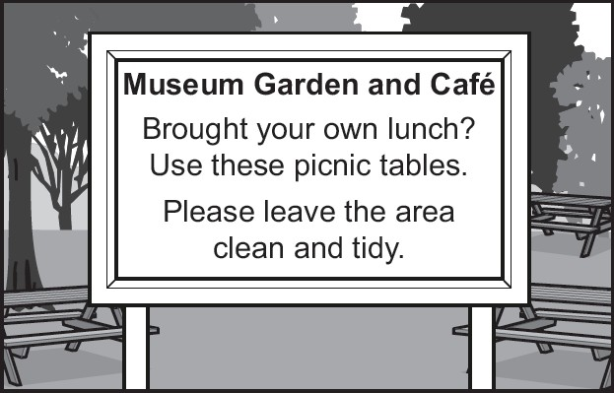
Visitors to the Museum Garden must not
A | eat in the garden.
B | drop any rubbish.
C | use the café tables for picnics.

Correct answer: B

So‘z, ibora yoki gapning ma’nosini anglash
Savollar 6–10
Nomzodlar beshta ta’rifni o‘qib, ta’riflangan so‘z yoki iborani tanlashlari kerak.
Namunaviy savol

This is a big animal with four legs. You can ride it.
A B  C | a fish a bird  a horse
To‘g‘ri javob: C

Muloqotning funksional maqsadini anglash
Savollar 11-15
Nomzodlar ikki kishi o‘rtasidagi beshta qisqa dialogni o‘qiydilar va ikkinchi
suhbatdosh qanday javob berishi kerakligini aniqlaydilar.

Namunaviy savol
A
B
C


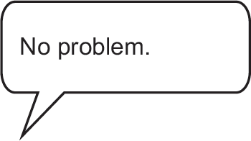

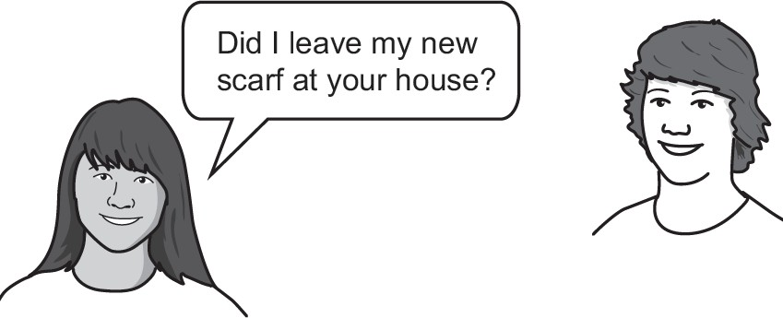



Correct answer: C

Mos so‘zni yoki grammatik shaklni aniqlash
Savollar 16-20
Nomzodlar beshta gapni o‘qiydilar va har bir tushirib qoldirilgan so‘z o‘rniga mos so‘zni tanlaydilar.
Namunaviy savol
Read the sentences about Zoe and her school.
For each space, choose the correct answer A, B or C.

Zoe goes to a school that’s her home.
A | near | B | from | C | between

Correct answer: A

Mos so‘zni yoki grammatik shaklni aniqlash
Savollar 21-25
Nomzodlar qisqa faktual matnni o‘qiydilar va tushurib qoldirilgan so‘z o‘rniga mos so‘zni tanlaydilar.
Namunaviy savol
Read the text about two buildings.
For each space, choose the correct answer A, B or C.
Two buildings with amazing roofs


The Sydney Opera House has one of the most famous roofs in the world. The architect who designed it loved sailing, (22) he made the roof look
like the sails of boats.
A | because | B | so | C | or

Correct answer: B

Tafsilotlarni tushunish
Savollar 26-30
Nomzodlar batafsil tushunish va asosiy g‘oyalarini anglash uchun nisbatan uzunroq matnni (taxminan 250–270 so‘z) o‘qiydilar, va beshta test savoliga (bir nechta variantli savollarga) javob beradilar.

Namunaviy savol
Read the text about a young woman who flew a plane around the world. For each question, choose the correct answer A, B or C.
19-year-old Zara Rutherford recently became the youngest woman to fly around the world alone. She had planned to do it in three months, but problems on the way added two months to her journey. She finally got home five months after leaving.
How long did Zara’s journey take?
A B  C | two months three months  five months
Correct answer: C

Tafsilotlarni tushunish
Savollar 31-35
Nomzodlar bir xil mavzudagi uchta qisqa matnga oid beshta savolni o‘qiydilar va har bir savolni to‘g‘ri matnga moslashtiradilar
Namunaviy savol
Read the texts below and the questions that follow.
For each question, choose the correct answer A, B or C.
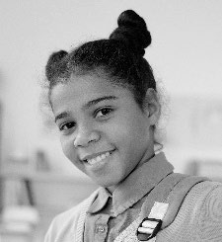

Shopping

Alessia
There’s a great shopping centre in my town. My friends and I go there together most weekends. It’s got clothes shops, sports shops, jewellery shops – every kind, really. We don’t buy much. We just look around and hang out. Sometimes I look at shopping websites on my phone, when I’m at home. I think about things I’d like to buy when I’m older and have a job.
Max
I didn’t enjoy going to shops when I was younger because I thought it was boring. But a few months ago, I found a great sports shop in the city, and I loved it. Then a similar one opened in my local town, and now I go there a lot. Actually, I don’t go in any other type of shop. This one has everything I need. Most of my friends go there, and it’s got a great website, too.
Clara
My older sister loves going out to the shops, but I don’t. If I have to go and choose a present for someone I’ll go, but I never go just for fun. I think it’s better to look for things to buy on the internet. It’s easier to find exactly what you’re looking for. When you go into clothes shops, for example,
they often don’t have your size, or the right colour.

Who prefers online shopping to going out shopping?
A  B C | Alessia  Max Clara

Correct answer: C

Tafsilotlarni tushunish
Savollar 36-40
Nomzodlar batafsil tushunish va asosiy g‘oyalarini anglash uchun nisbatan uzunroq matnni (taxminan 250–270 so‘z) o‘qiydilar, va beshta test savoliga (bir nechta variantli savollarga) javob beradilar
Namunaviy savol

Read the text about a girl who makes podcasts.
For each question, choose the correct answer A, B or C.
My life as a podcaster
by 14 year-old Maya Fellows

When I was 9, I started listening to podcasts for children – talk shows that you download from the internet – but all I could find were kids’ stories, or shows about fashion. I wanted to understand the news, but there was nothing available, so I decided to start one myself.
What is Maya’s podcast about?
A B  C | fashion news  science

Correct answer: B

Qabul jarayonida nomzodlarni saralash qoidalari

Qabul imtihonida to‘plangan ballar Xorijiy tillarga ixtisoslashtirilgan xalqaro maktab-internatiga qaysi nomzodlar qabul qilinishini belgilaydi.
Har bir sinf uchun nomzodlarni saralash quyidagi ketma-ketlik asosida amalga oshiriladi:
- Umumiy ball
- Ingliz tili testi natijasi
- (Ballar teng bo‘lib qolgan taqdirda) ingliz tilining o‘qish ko‘nikmasi bo‘yicha natija
- (Ballar teng bo‘lib qolgan taqdirda) ingliz tilining grammatika bo‘limi bo‘yicha natija
- Matematik fikrlash va tanqidiy tahlil ko‘nikmalari testi natijasi
- (Ballar teng bo‘lib qolgan taqdirda) matematik fikrlash va tanqidiy tahlil ko‘nikmalari testining tanqidiy fikrlash bo‘limi bo‘yicha natija
Agar yuqoridagi mezonlardan so‘ng ham nomzodlarning ballari teng bo‘lib qolsa, yoshi kichik bo‘lgan nomzod yuqoriroq o‘ringa qo‘yiladi.





Cambridge University Press & Assessment The Triangle Building
Shaftesbury Road Cambridge
CB2 8EA
United Kingdom
partnership@cambridge.org • cambridge.org/partnership • +44 1223 358331

